T z
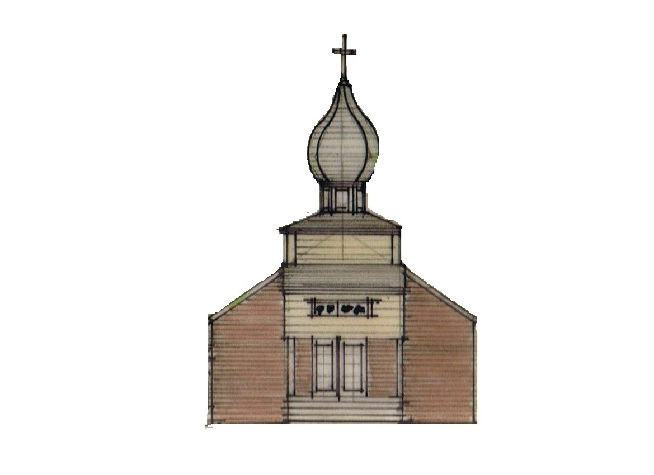
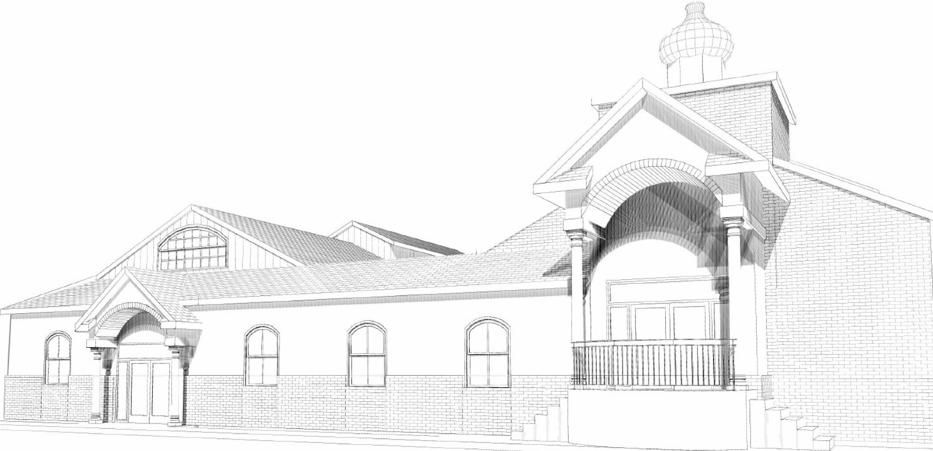

St. Michael the Archangel Orthodox Church

2300 W. Huntington Drive, Kirkwood Hwy, Wilmington, Delaware 19808

Rev. James Weremedic, Rector • (302) 995-6775 • Cell (570) 764-4323

Email: frjamesw@hotmail.com • Web: www.stmichael-delaware-oca.org

Vespers & Confessions: Saturday, 4:00 pm

Hours, Divine Liturgy & Fellowship: Sunday, 8:40 am

Sunday, January 12, 2014

29th SUNDAY AFTER PENTECOST. Tone 4. Afterfeast of the Theophany. Sunday after Theophany. Martyr Tatiana of Rome and those who suffered with her. St. Sava I, first Archbishop of Serbia. Ven. Martinian, Abbot of Belozérsk. Martyr Mertius of Mauretania . Martyr Peter Apselamus of Palestine. Ven. Eupraxia of Tabenna, in Egypt.
Reader’s Schedule

DATE 3RD HOUR 6TH HOUR EPISTLE
Jan-12 WEREMEDIC, J WEREMEDIC, L. CAREY
Jan-19 RILEY, J RILEY, A PECK
Jan-26 BUNITSKY, K. BUNITSKY, S. WEREMEDIC, J.

Date | Fellowship  Coffee Hour | Service  Duty | Church Cleaners | Library
12-Jan | Hojnick, Flynn  Roberts | Riley  Baldytchev | Finck | Nichols
19-Jan | Kraiter, Cretu | Sulpizi, Finck | Whalen | Farrell
26-Jan | Gerassimakis,  Bunitsky | Souder, Poletaev | Shatley, Baldytchev | Gregors
2-Feb | Morjana, Whalen, Bisrat | Bunitsky, Kendall | Kutch, Sulpizi | Dozier

We are not holding Vespers on Saturday, January 18, 2014 as the Diocisan Assembly will be held on Friday, January 17th and 18th in Bethlehem. Father James and James Carpenter will be attending and will probably return late Saturday evening.
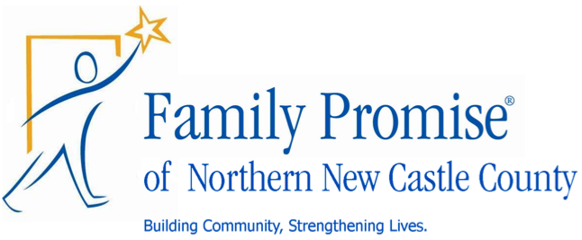 What is Family Promise?

Family Promise is a network of churches and synagogues that host homeless families for a week at a time. Four or five homeless families – parents and children – come to live in our church 3 to 4 times a year.
How does this work? Our classrooms become bedrooms with inflatable mattresses, bedding, and care packages. Volunteer van drivers bring the program’s current families from the Family Promise Center to our church every evening of the host week. A network of organized volunteers then fill in roles in the church building each night of the host week to collectively cook dinner for the families plus volunteers (about 20 people) and remain in the church with our guests as hosts to offer comfort and companionship during their stay. Two volunteers spend the night in the building (sleeping is encouraged!) in a private room and set out breakfast supplies for the families before they are driven back to the center again where they shower, the kids catch the school bus, and the parents work with the Family Promise staff on finding jobs or housing.
Does this sound like homeless ministry as you know it? Our job is hospitality, conversation, prayer, and welcome.

What can you do to help?
St. Philip’s Lutheran Church has been hosting for about 3 years. We are blessed with ample room to host our guests but we are always in need of caring volunteers who are able to help us host the families. We don’t fix their problems; we just provide a safe, comfortable, and friendly place. We’re looking for St. Michael’s help to cover each of our volunteer roles! Individuals, small groups, and families with kids are encouraged. Roles are organized in such a way that any one volunteer can volunteer for just one short session or for multiple sessions throughout the host week. If you can cook a meal, spend a night, drive a van, or just come and be friendly, we could use your help! St. Philip’s next Host Week is February 9th – February 16th!!!
If you are interested in participating with Family Promise, please contact Brandon and Karen Zinnato at (302) 229-6032 or novemberbasket@yahoo.com. Volunteers are requested to attend an orientation on Sunday January 26th at St. Phillip’s hall following our Fellowship Hour.

Ephesians 4:7-13 (Epistle, Sunday After)
But to each one of us grace was given according to the measure of Christ’s gift. Therefore He says: “When He ascended on high, He led captivity captive, And gave gifts to men.” (Now this, “He ascended” – what does it mean but that He also first descended into the lower parts of the earth? He who descended is also the One who ascended far above all the heavens, that He might fill all things.)
And He Himself gave some to be apostles, some prophets, some evangelists, and some pastors and teachers, for the equipping of the saints for the work of ministry, for the edifying of the body of Christ, till we all come to the unity of the faith and of the knowledge of the Son of God, to a perfect man, to the measure of the stature of the fullness of Christ;

Matthew 4:12-17 (Gospel, Sunday After)
Now when Jesus heard that John had been put in prison, He departed to Galilee. And leaving Nazareth, He came and dwelt in Capernaum, which is by the sea, in the regions of Zebulun and Naphtali, that it might be fulfilled which was spoken by Isaiah the prophet, saying: The land of Zebulun and the land of Naphtali, By the way of the sea, beyond the Jordan, Galilee of the Gentiles: The people who sat in darkness have seen a great light, And upon those who sat in the region and shadow of death Light has dawned.”
From that time Jesus began to preach and to say, “Repent, for the kingdom of heaven is at hand.”

Ancient Faith Today with Kevin Allen will host Orthodox priest Fr. Josiah Trenham, for a discussion of “Sex, Virginity, and Marriage in the Orthodox Church” live this Sunday, January 12, at 8 pm. The V. Rev. Fr. Josiah Trenham, pastor of Saint Andrew Orthodox Church, Riverside, California, and the author of the recently published Virginity and Marriage According to Saint John Chrysostom (St Herman Press) will discuss views of the church fathers and the contemporary Orthodox Church on sex, marriage, and celibacy (monasticism) in the context of a sex-obsessed contemporary Western culture. Listen live by pointing your internet browser to www.ancientfaith.com and clicking on the “talk” button. The program will also be available as part of the Ancient Faith Today with Kevin Allen podcast.
Prayers for the Departed: Sorin Ojog, Noria Morjana, Dorothy Jones.

Prayers for the Sick and Needy: Mat. Lisa Weremedic, Infant Jordan, Alice Dryden, William Dryden, Agnes Timchak, Wendy Boyer, Olga Riley, Anna Hotrovich, Mary Guretsky, Marie Holowatch, Joseph Wojciechowski, Keith Eldridge.

We welcome our visitors and guests and invite you to join us for coffee hour in the church hall following the Liturgy.

Jeremy and Catalina joyfully invite the parish family to witness and celebrate the baptism of their daughter Catherine on Saturday, January 25 at 2pm.

Our Joint 2014 Winter Wilmington Parish Gathering of parishioners from Ss. Peter and Paul and St. Michael will be on Friday, February 28. A new team, 87’ers, a development team for the 76’ers are playing in the Bob Carpenter Center in Newark, DE against the Sioux Falls Skyforce (Heat). Tickets are $15 per person. If anyone is interested, please sign-up on the form in the Vestibule. If we have at least 15 people going, our ‘Fan Experience’ at the game will be a “Chalk Talk” with the 87ers coaching staff about their plans for the game, in a meeting held in the locker rooms during the first minutes of warm-ups.

The sign-up sheet for House Blessings is in the narthex. Please indicate your preference for morning, afternoon or evening appointment. In addition, please indicate the days you will not be available. Father will schedule based on the information provided and will confirm a date/time with you. In addition, please provide a phone number to confirm appointments. All those who signed up last week are scheduled.

Our Bible Study Group continues to meet on the 1st and 3rd Thursday of each month from 10:00 am - 12:00 noon. We continue to use Barbara Pappas's book First and Second Corinthians for direction.

