T z
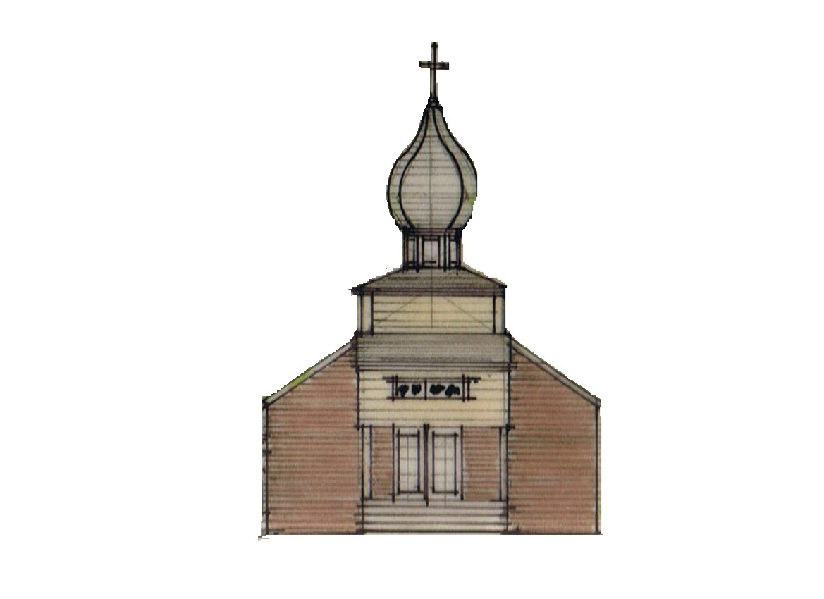
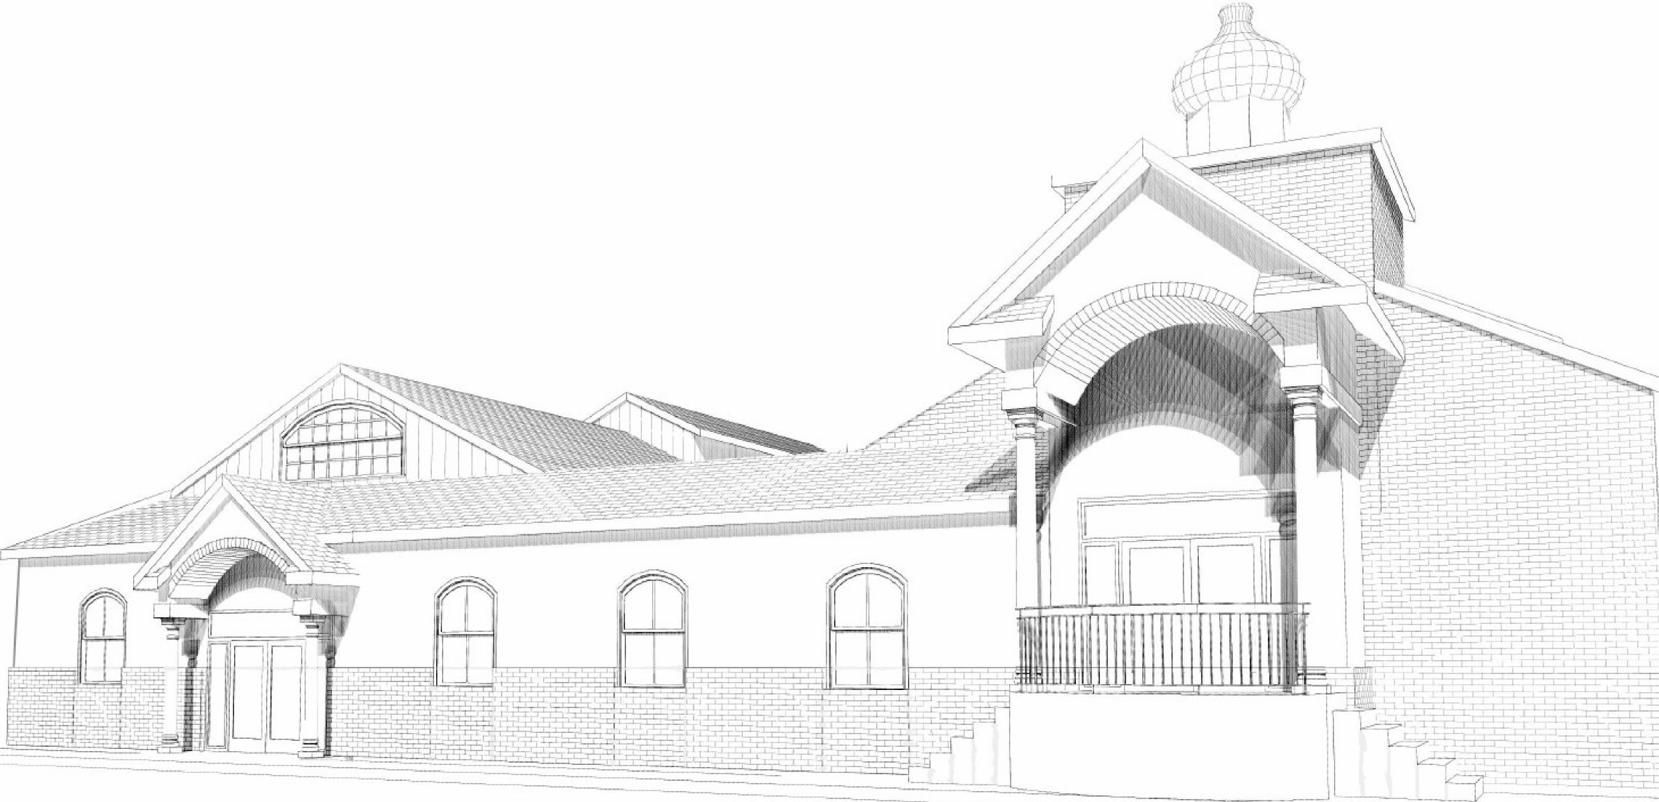

St. Michael the Archangel Orthodox Church

2300 W. Huntington Drive, Kirkwood Hwy, Wilmington, Delaware 19808

Rev. James Weremedic, Rector • (302) 995-6775 • Cell (570) 764-4323

Email: frjamesw@hotmail.com • Web: www.stmichael-delaware-oca.org

Vespers & Confessions: Saturday, 4:00 pm

Hours, Divine Liturgy & Fellowship: Sunday, 8:40 am

Sunday, December 15, 2013

25th SUNDAY AFTER PENTECOST. Tone 8. Sunday of the Forefathers. Hieromartyr Eleutherius, Bishop of Illyria, and his mother, Martyr Anthia. Ven. Paul of Latros. St. Stephen the Confessor, Archbishop of Surozh in the Crimea. Ven. Tryphon, Abbot of Pechenga, and his martyred disciple, Jonah. Martyr Eleutherius at Constantinople. Ven. Pardus, Hermit, of Palestine.
Reader’s Schedule

DATE 3RD HOUR 6TH HOUR EPISTLE
Dec 15 WEREMEDIC SOUDER CARPENTER
Dec 22 CARPENTER SENSOR WALES
Dec 29 RILEY, A RILEY, J PECK

Date | Fellowship Coffee Hour | Service Duty | Church Cleaners | Library
15-Dec | Lemlem Kiflemarian | Souder Poletaev | Riley | Dozier
22-Dec | Manna Berhane Mihret | Bunitsky Kendall | Carey Bunitsky | Gundersen
29-Dec | Rectory Open House | Morjana | Peck Dozier | Nichols

Poinsettia orders for Nativity decoration deadline is today. Please use the order forms in the narthex and return attached to your cash or check in the envelopes provided. You may make dedications on the form.
 What is Family Promise?

Family Promise is a network of churches and synagogues that host homeless families for a week at a time. Four or five homeless families – parents and children – come to live in our church 3 to 4 times a year.

How does this work? Our classrooms become bedrooms with inflatable mattresses, bedding, and care packages. Volunteer van drivers bring the program’s current families from the Family Promise Center to our church every evening of the host week. A network of organized volunteers then fill in roles in the church building each night of the host week to collectively cook dinner for the families plus volunteers (about 20 people) and remain in the church with our guests as hosts to offer comfort and companionship during their stay. Two volunteers spend the night in the building (sleeping is encouraged!) in a private room and set out breakfast supplies for the families before they are driven back to the center again where they shower, the kids catch the school bus, and the parents work with the Family Promise staff on finding jobs or housing.
Does this sound like homeless ministry as you know it? Our job is hospitality, conversation, prayer, and welcome.

What can you do to help?
St. Philip’s Lutheran Church has been hosting for about 3 years. We are blessed with ample room to host our guests but we are always in need of caring volunteers who are able to help us host the families. We don’t fix their problems; we just provide a safe, comfortable, and friendly place. We’re looking for St. Michael’s help to cover each of our volunteer roles! Individuals, small groups, and families with kids are encouraged. Roles are organized in such a way that any one volunteer can volunteer for just one short session or for multiple sessions throughout the host week.
If you can cook a meal, spend a night, drive a van, or just come and be friendly, we could use your help!
Keep an eye open for upcoming volunteer trainings and sign-up! If you are interested in learning more about Family Promise, please contact Brandon and Karen Zinnato at novemberbasket@yahoo.com or (302) 229-6032.
St. Philip’s next Host Week is February 9th – February 16th!!!
Prayers for the Departed: Dorothy Jones, James Paffhausen.

Prayers for the Sick and Needy: Mat. Lisa Weremedic, Mat. Elizabeth Bacon, Matushka Vera Yuschak, Mark, Alice and William Dryden, Agnes Timchak, Wendy Boyer, Olga Riley, Anna Hotrovich, Mary Guretsky, Marie Holowatch, Joseph Wojciechowski, Taylor, John Vianski, Keith Eldridge.

Prayers for Celebration: Rd. James Weremedic celebrating his birthday this week.

Prayers for the newly born Catherine Rosario Finck, daughter of Jeremey and Catalina Finck.

Volunteers needed to decorate the church and Christmas tree on Saturday, Dec. 21st in the afternoon. Please sign up in the narthex.

We are planning a Joint Winter Wilmington Parish Gathering of parishioners from Ss. Peter and Paul and St. Michael. A new team, 87’ers, a development team for the 76’ers are playing in the Bob Carpenter Center in Newark, DE. We have a few tentative dates in February (4, 10, 21 and 28) and will be selecting one in the near future. Tickets will cost approximately $15 per person. If anyone is interested, please talk to Fr. James. If we have at least 25 people going, we may be able to have a ‘Fan Experience’ at the game.

Our Bible Study Group continues to meet on the 1st and 3rd Thursday of each month from 10:00 am - 12:00 noon. We continue to use Barbara Pappas's book First and Second Corinthians for direction.

Our 4th Annual Parish-wide Holy Supper held on Christmas Eve at 4:00 pm. (Compline Service will begin at 6:00 pm.) Copies of the Holy Supper book for our Christmas Eve preparation are available in the Parish Book Store. Anyone may attend the Holy Supper and for those wishing to bring their lenten favorite may feel free. Please sign on the sheet so we prepare enough food.
YTD Financial Status
Income from operations |  | $ 149,685.31
expenses for operations |  | $(154,838.85)
year to date income/(loss) - Oct |  | $ (5,153.54)

Orthodox Church in America Philadelphia Deanery
Annual St. Herman of Alaska Lecture

Sunday December 15,
St. Stephen’s Cathedral, 8598 Veree Road, Philadelphia, Pa
4:00 pm Akathist Hymn to St. Herman of Alaska
5:00 pm Lecture: Using Social Media to Spread the Gospel
Fr. Andrew Stephen Damick,
Pastor, St. Paul’s Antiochian Orthodox Church, Emmaus, Pa
Podcaster: Ancient Faith Radio, Roads from Emmaus and Orthodoxy and Heterodoxy
Author: Orthodoxy and Heterodoxy, Ancient Faith Publishing, 2011
Weblogs: Roads from Emmaus and Orthodoxy and Heterodoxy

Luke 14:16-24 (Gospel)
Then He said to him, “A certain man gave a great supper and invited many, and sent his servant at supper time to say to those who were invited, ‘Come, for all things are now ready.’ But they all with one accord began to make excuses. The first said to him, ‘I have bought a piece of ground, and I must go and see it. I ask you to have me excused.’ And another said, ‘I have bought five yoke of oxen, and I am going to test them. I ask you to have me excused.’ Still another said, ‘I have married a wife, and therefore I cannot come.’ So that servant came and reported these things to his master.
Then the master of the house, being angry, said to his servant, ‘Go out quickly into the streets and lanes of the city, and bring in here the poor and the maimed and the lame and the blind.’ And the servant said, ‘Master, it is done as you commanded, and still there is room.’
Then the master said to the servant, ‘Go out into the highways and hedges, and compel them to come in, that my house may be filled. ’For I say to you that none of those men who were invited shall taste my supper.

